11.4 Oxides
Name: ____________________ Class: ____________________ Due date:
1. Air containing an acidic impurity was neutralised by passing it through a column containing substance X.
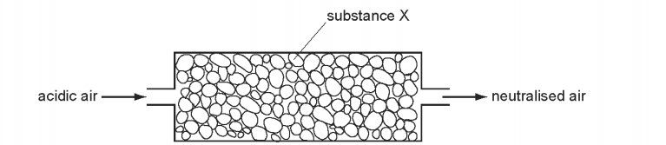
What is substance X? （ ）
A calcium oxide
B sand
C sodium chloride
D concentrated sulfuric acid

2. Which of the following are properties of the oxides of non - metals? （ ）
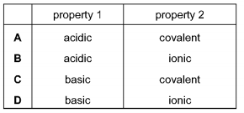

3. Element X forms an acidic, covalent oxide.
Which row shows how many electrons there could be in the outer shell of an atom of X? （ ）
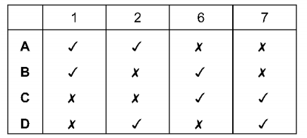

4. Two oxides, X and Y, are added separately to dilute sulfuric acid and dilute sodium hydroxide.
X reacts with dilute sulfuric acid but Y does not react.
Y reacts with aqueous sodium hydroxide but X does not react.
Which type of oxide are X and Y? （ ）
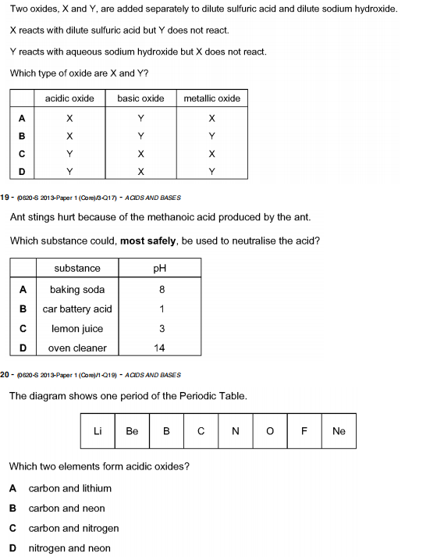
5. The diagram shows one period of the Periodic Table.
Which two elements form acidic oxides? （ ）
A carbon and lithium
B carbon and neon
C carbon and nitrogen
D nitrogen and neon

6. Element X forms an oxide, XO, that neutralises sulfuric acid.
Which row describes X and XO? （ ）
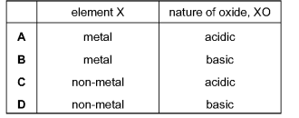
7. The positions of elements W, X, Y and Z in the Periodic Table are shown.
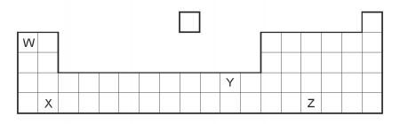
Which elements form basic oxides? （ ）
A W, X and Y B W and X only C Y only D Z only
9. The diagram shows a simplified form of the Periodic Table:
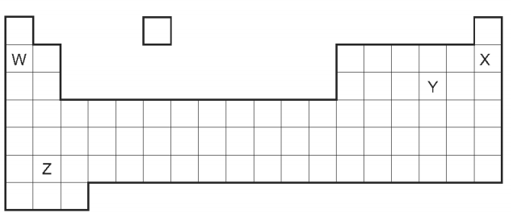
Which elements will form an acidic oxide? （ ）
A W and Z
B W only
C X and Y only
D Y only

10. Which statement about oxides is correct? （ ）
A A solution of magnesium oxide will have a pH less than 7.
B A solution of sulfur dioxide will have a pH greater than 7.
C Magnesium oxide will react with nitric acid to make a salt.
D Sulfur dioxide will react with hydrochloric acid to make a salt.

11. Element X is in Group I of the Periodic Table.
Which row shows the type of oxide and whether element X is metallic or non-metallic? （ ）
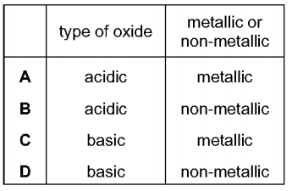

12. Which row describes whether an amphoteric oxide reacts with acids and bases? （ ）
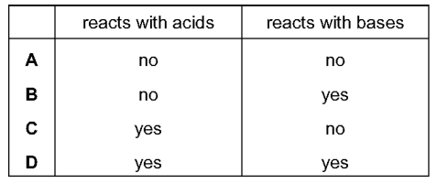

13. Germanium oxide is a white powder. （ ）
Germanium oxide reacts with concentrated hydrochloric acid.
Germanium oxide reacts with concentrated aqueous sodium hydroxide.
Germanium oxide does not dissolve when added to water.
Which type of oxide is germanium oxide?
A acidic B amphoteric C basic D neutral

